**CUBMASTER**

**HANDBOOK**

**PACK 628**

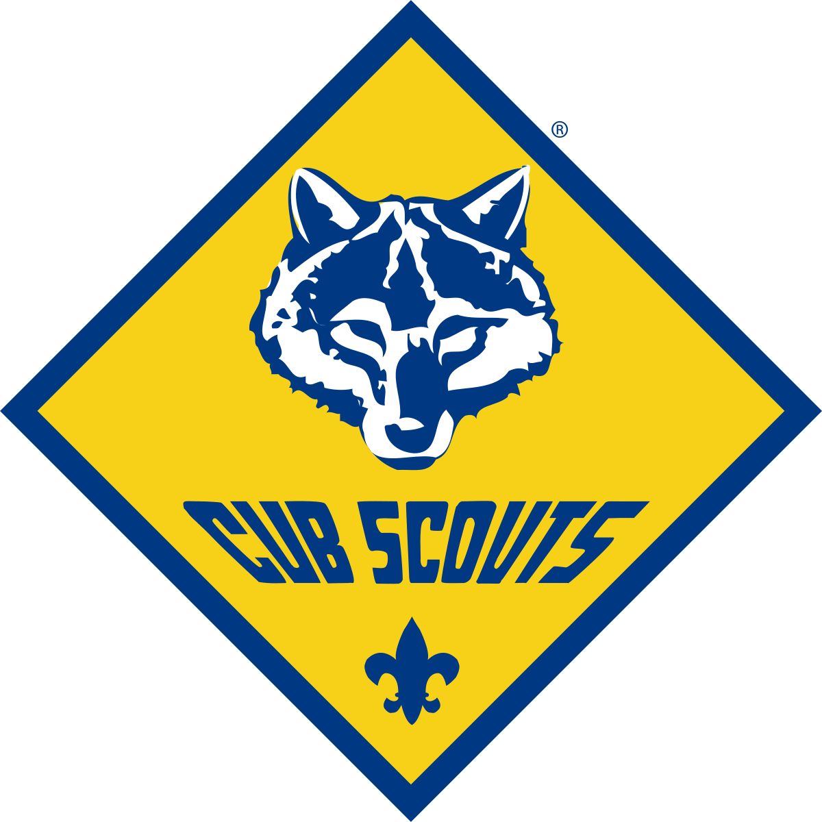

Contents

Introduction 3

Pack & Den Meetings 4

Scoutbook 4

Cabana/Storage 4

Pinewood Derby 5

***Setup*** 5

***Check-In*** 6

***Race Day*** 6

Walkersville Watershed 7

Facility Reservations 7

Scouting for Food 8

Rocket Launch 8

Bridging Ceremony 8

# Introduction

Welcome to Pack 628! This handbook will serve as a guideline of things you will be responsible for as Pack 628’s Cubmaster as well as some tips learned from previous Cubmaster’s in year’s past. The Cubmaster is responsible for the safety of all scouts and as the face of the organization you need to demonstrate an organized and calm demeanor, even if you don’t have all the answers, but most importantly make sure that scouts and families have the most fun as possible. As you continue your Cubmaster journey and learn what works and doesn’t work, please feel free to update this document as you see fit.

# Pack & Den Meetings

As you probably already know the Pack typically meets twice a month for Den meetings and once a month for Pack meetings. During Den meetings the Den Leaders will be responsible for whatever activity their respective Den will be working on so as Cubmaster you will just make sure that everybody has what they need, and that scouts and families are following directions and staying safe. One tip I found helpful is that after the opening flag ceremonies and once the Dens divide to work on their activities, gather all parents around to make any announcements you might have. This way not only are you having one-to-one interaction with the parents and be able to answer any questions they might have, it also gives the scouts as much time with their Dens as possible.

The Pack meetings, which are typically held the last Wednesday of every month, consists of opening/closing flag ceremonies, any announcements you might have, advancements/awards that need to be recognized, and whatever Pack activity yourself and the Committee agree to do. You will oversee whatever activity is done whether it be a simple craft project, a community service project, etc. Again, make it safe but most importantly make it fun!

For all meetings make sure you have the Pack’s 4 flag stands and 4 flags (American, State, Pack, and Lions Club). Assign a color guard with 1 announcer for each meeting and try and allow different scouts to participate throughout the year. Flags will either need to be returned to the cabana or wherever you prefer to store them in between meetings; for me it was easier just to keep them at my house so I didn’t have to make multiple trips to the cabana.

# Scoutbook

Scoutbook is the lifeline of the Pack. It is used for all Pack communication, scout advancements/awards, and memberships. Make sure that you are familiar with all aspects of the application. You should be able to enter advancements/awards for any scout in addition to managing Dens and creating new ones when needed. The purchasing of scout advancements and awards is the responsibility of the Advancement Chair but you should be regularly logging in to officially approve any earned advancements/awards.

# Cabana/Storage

The Pack has two storage facilities, or cabana’s, located at the Coldstream Pool of Lake Linganore. All the Pack’s items such as camping supplies, the Pinewood Derby track, sound equipment, and other miscellaneous items are stored there. The Lake Linganore Association (LLA) has always granted the Pack access to these cabanas without any associated cost. Cabana’s #9 and #10 are the two storage units.

To enter Coldstream Pool during off hours you will need to unlock and open the main gate. There is a key storage container attached to the outside of the gate and requires a code to open it. The LLA used to change the code annually, but it has been “1999” for many of the past years. If for some reason the code is changed you will need to contact the LLA to obtain the new code. Each of the two cabanas’ have a padlock on the door with a three-digit code. The code for both cabana’s is “628”.

# Pinewood Derby

The Pinewood Derby is the Pack’s biggest event of the year. An event of this size will require lots of planning and coordination amongst all the leaders, committee members, and even outside parties. It is always held on a designated Saturday in February with the setup and check-in of cars the night before.

The Pack is lucky enough to have the assistance from John Stalnaker who provides electronic equipment such as the automatic start gate, light tree, finish gate, and all the custom PC hardware/software necessary to run the event. His email address is [john@stalnakersolutions.com](mailto:john@stalnakersolutions.com) and his phone number is (301) 471-2052. You will need to coordinate with Mr. Stalnaker months before the Pinewood Derby to determine the date of the race and any special items he may require. Lastly, the Pack typically makes an annual donation to Mr. Stalnaker to allow him to update his hardware/software as needed; make the Treasurer and Committee aware of this.

The Pack also has the assistance of Boy Scout Troop 628 who will volunteer a few of their scouts to be runners. Runners are those who take the cars from the finish line back to the organization table. You or a committee member will need to contact the Troop and coordinate this with them.

## Setup

The night before the race, the track and all other components of making the event run smoothly will need to be setup in the designated location. Most of the items to be used by the Pack are stored in the Cabana. The track, sorting trays, scales, clearance templates, sound and audio equipment, and projector screen are all stored within the cabana. Plan with somebody who has a truck or other big vehicle for transportation of the items needed. Also, recruit leaders/parents to help you with this as the items, specifically the track, are very heavy and cannot be lifted by a single person. John Stalnaker will provide all other electronic equipment needed to run his race software. If using a Frederick County location such as a cafeteria in one of the schools a reservation will need to be made as soon as possible not only for the race itself but for the night of setup and check-in.

When reserving the location make sure to give yourself enough time as possible to set everything up as it will take several hours to do so. As a good faith gesture the Cubmaster typically hangs around until the very last minute and offers to provide dinner to the volunteers in the form of pizza or subs or something else. Remember, as Cubmaster it’s best if you dictate out responsibilities and this is critical to get everything set up properly. Assign a few volunteers to work on the track, others to set up and move tables, and others to set up the check-in tables.

The Pinewood Derby track is quite long and will run the full length of a school cafeteria so plan the layout accordingly.

## Check-In

All scouts, siblings, and adults that have signed up to race need to check in their cars the night before the race for inspection. It’s best to have multiple leaders assist in this while other leaders and/or parents are helping set up the track and electronic equipment. While all this takes place it will be your job to make sure that no parents or kids go near or step over the track!

The key components of car check-in are weight, length/height, clearance, wheels, and lubricants. The Pack follows the District’s Super Derby rules in which each car cannot exceed 5.00 ounces weighed to the hundredth of a gram, cannot exceed 5 inches in height, 7 inches in length, and 3 inches in width.

During the check-in process a scout will one at a time bring their finalized car to the table and will first be weighed. If they exceed 5.00 ounces, they will need to use a provided Dremel or other tools to take weight off. If they are below 5.00 ounces, they have as many opportunities as possible to add weight until they are comfortable with checking it in. After the weight is confirmed then a template/guide will be used to determine that the body of the car will clear the trac and that there is no rubbing from either the body or the wheels/axels. The wheels cannot be altered in any way except for paint and a little bit of sanding to smooth it out; they cannot be made slimmer or machined in any way. The axels can in fact be bent as well as raised as long as 3 wheels are touching the track at all times. Lastly, the scout can add a dry lubricant such as graphite to the wheels and axels; NO LIQUID LUBRICATION. It is HIGHLY suggested that a trash bag or two is taped to the table where graphite is applied. If graphite gets on the school lunch tables, it is extremely hard to get off. Once all this is completed the car will be officially checked in, the scout will receive a racer’s card, and the car cannot be touched until the completion of the race.

## Race Day

The morning of the race yourself and any other volunteers will show up early to finalize any setting up that needs to be done. This includes making sure all the electronic start and finish line system works, the race schedule is finalized, and if live streaming that a strong signal is present and ready. Tables will be set up around the perimeter of the track for people to sit and the scouts can sit next to the track outside of the yellow cones and safety line.

Try and begin the race right on time as you will only have the cafeteria or other location reserved for a specific period. Other leaders will assist you in organizing each race heat, loading cars onto the track, and John Stalnaker will be responsible for making sure all the race software runs smoothly. You or another designated leader/parent will be assigned as the race commentator to make the event more fun. During the race make sure all scouts and families adhere to the safety ropes and do not cross it or lean on them. We have had scouts get hurt in the past not listening to this and either get hit by the runners or have a safety post fall over and hit them.

Once all race heats are completed John Stalnaker will print out the race results. You will then present the winners of each category with either a certificate or a trophy. The scout with the top overall fastest car of the day will be presented with a Pack plaque where a custom engraved plate will be added. The scout gets to keep this plaque for the remainder of the year to be returned at the next year’s race.

After all awards are handed out and the race is completed begin breaking down and cleaning up. The track will need to be carefully put back in the storage box, all tables put back to their original locations, and all electronic equipment broken down according to John Stalnaker instructions.

# Walkersville Watershed

Pack 628 uses the Walkersville Watershed for a lot of outdoor activities. To make any reservations you will need to contact Ron Layman who oversees maintaining the property. His phone number is (301) 788-7496 and his email is [layman274@gmail.com](mailto:layman274@gmail.com). They are very accommodating to the Pack, but we need to be respectful in the fact that we are using the Boy Scouts property. Make sure all trash is cleaned up and taken with you, any fires are put out properly, and all items are put back to their original locations.

# Facility Reservations

In order to use the DCES cafeteria for Den/Pack meetings and special events such as the Pinewood Derby the facility needs to be reserved each season through Frederick County Public Schools (FCPS). The point-of-contact is Deborah Walukonis; email [deborah.walukonis@fcps.org](mailto:deborah.walukonis@fcps.org). In order to do this, navigate to <https://www.fcps.org/uof> and use their online facility reservation system.

The request form submission period, which may vary year to year, is listed below:

*Fall Reservation: June 1-15*

*Winter Reservation: October 1-15*

*Spring Reservation: January 1-15*

Additionally, in order to be able to use FCPS facilities the Pack needs to provide a Certificate of Insurance (COI). The COI covers the Pack for a full year and when a new one is needed you will need to contact our BSA District representative and submit it to Deborah Huffman.

# Scouting for Food

During the Fall the Pack assists Boy Scout Troop 628 with the Scouting for Food program. This is one event where the Pack doesn’t have to do much organizing since Troop 628 is responsible for that. A representative from the Troop should reach out to you sometime in August or September asking if we are willing to help. Once available they will provide our Pack dates and times of the bag drop-off and food pick-up as well as which neighborhoods, we are responsible for. For both drop-off and pick-up, we begin at Deer Crossing Elementary School parking lot to organize and receive any specific instructions from Troop 628.

Your job as Cubmaster is to delegate which scouts are going to cover which neighborhoods based on which ones are assigned to the Pack. The best idea is to have the younger scouts cover the easier neighborhoods such as Summerfield. A good suggestion is to have a check-in sheet, so scouts sign in as they show up to help you mark off service hours and any advancements/awards in Scoutbook.

# Rocket Launch

During the Fall, usually on a Saturday in November, the scouts launch model rockets in coordination with the local NARHAMS rocket club. We again coordinate with John Stalnaker on dates and times, and he assists the Pack with the proper loading and preparation of the rocket engines. His email address is [john@stalnakersolutions.com](mailto:john@stalnakersolutions.com) and his phone number is (301) 471-2052. Due to the Pack’s size, we have split up into two groups launching rockets during two different time frames. For example, if the rocket club is scheduled for 12-4PM we have one group of scouts from 12-2PM and the second group from 2-4PM. It’s best to reach out to John Stalnaker several months ahead of time to make sure he is willing to assist again and around that same time it would be wise for the Pack’s Committee to begin purchasing rockets as needed.

# Bridging Ceremony

As Cubmaster you will be responsible for scheduling and executing the Bridging Ceremony. The Bridging Ceremony is for AOL scouts who are transitioning into Boy Scouts and therefore leaving Pack 628. Typically, this takes place on a Friday or Saturday evening in March and those who join Troop 628 can campout that very same weekend. The ceremony is a time-honored tradition and needs to be treated with the upmost respect. It is held at Troop 628’s campfire area at the Walkersville Watershed and all Boy Scout Troops that the scouts are bridging into will need to be there as they typically present the scouts with their new uniform neckerchiefs at the completion of the ceremony. The detailed instructions of the ceremony itself can be found on the Pack’s website under the “General Leader Resources” link under the “Leader Resources” main menu.

Some prep-work for the ceremony will need to be done ahead of time. The Arrow of Light tiki holder is a wooden AOL symbol that holds tiki torches lit by the scouts during a specific point during the ceremony. Make sure that there is enough tiki fuel for all the torches and if not, the Pack buys more. The AOL tiki holder, the tiki torches, and the torch fuel can be found in the cabana. Some tips I’ve learned over the years is to bring a funnel to the ceremony to easily fill the torches with fuel without spilling all over the place. Bring disposable gloves to keep your hands clean from the fuel and even baby wipes or sanitary wipes incase some fuel does get on your hands; the fuel is very hard to get off. Depending on the time of the day of the ceremony make sure you bring proper lights, such as headlamps or flashlights, to read the ceremony script. Do not bring the Milwaukee camping lights because the ceremony is supposed to be lit only by nature and the tiki torches.

Lastly, some tasks will need to be completed by the scouts and/or their parents. These tasks include career arrows, talking feathers, and words of pride and reflection which are presented to the scouts during the ceremony. The career arrows are provided by the Pack and can be worked on with the Den Leader during a designated Den meeting or on their own. Each scouts’ parents are responsible for writing some words of pride, reflection, and encouragement to be read during the ceremony when their scout is called forward. These words are usually a paragraph long and will need to be collected from the parents ahead of time. Coordinate with the Pack Committee, specifically the Treasurer, on the purchasing any items needed for the arrows and talking feathers.